CASE WRITING - SBC103 PRINCIPLES OF SOCIAL BUSINESS EXECUTION

RISK MANAGEMENT FOR TR’DIN SYRUP PROJECT
Author: Huynh Bach Khoa (team Forest Food)

I. Introduction
According to Startup Failure Rate Statistics (2023), up to 90% startups fail [1]. On average, 10% will fail in year one, and 45% will fail in year 2 to 5. Many risks such as poor product-market fit, wrong marketing strategy, team issues... may cause a startup to fail. As a result, risk management is very importance in ensuring the project can progress steadily, anticipating & mitigating potential problems. This paper aims to study risk management in Forest Food’s “Tr'din Syrup” project. We will analyze its potential risks and recommend possible actions to mitigate them.

II. Risk analysis for Tr'din Syrup project
Here are some potential risks of the Tr'Din Syrup project:

1. Product Risk: 1/5
Product risk is the risk associated with product development [2]: What is the product? What problems does it solve? What is the market for it? How does it fit into the landscape? How can it compete? Can we actually develop it? Why is it worth investing in?
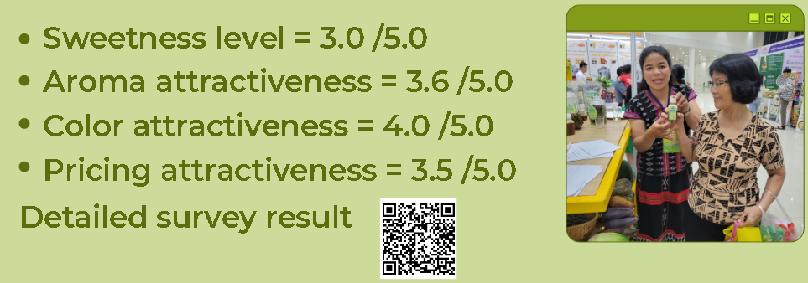
Figure 1. Survey on Tr'din syrup sweetness, aroma, color and pricing attractiveness

For Tr'din syrup, we have developed the product prototype, introduced it in Da Nang city’s Vietnamese Products Fair, and surveyed visitors’ opinions. Overall, it is well-liked by visitors, tasty, not too sweet, nice aroma and has a pleasant color. They like its natural mountain forest origin, and its feature of not increasing blood sugar level. Some visitors want it to be sweeter to make drinks, so we should offer a sweeter version. And people advise us to do marketing strongly for people to know as our product is very new.

Compare to other competitors in the natural sweetener market, we aim to offer it a competitive price at 16 USD/L (B2B) or 20 USD/L (B2C) since we harvest it from existing Tr'din forest trees in in cooperation with the mountain villages here, and make use of a large available land in Tay Giang. The global natural sweetener market is over 10.5 billion USD in 2022, and is expected to grow 4% CAGR from 2023 to 2032 [4]. So Tr'din has the potential to join a large global market.

We estimate Tr'din syrup product risk is 1/5, as we have developed the prototype and surveyed customer opinions. The global market is large, and we can have a competitive price compared to some competitors.

2. Market Risk: 3.5/5
Market risk is the risk that arises from consumer preferences, market competition and economic flunctuation. Poor product-market fit accounts for 34% of startup failures and wrong marketing strategy leads to 22% [1], so in total market risk accounts for 56% of startup failure, the most common cause. As a result, it is utmost important to conduct a thorough market research to ensure the product can be successful in the market.

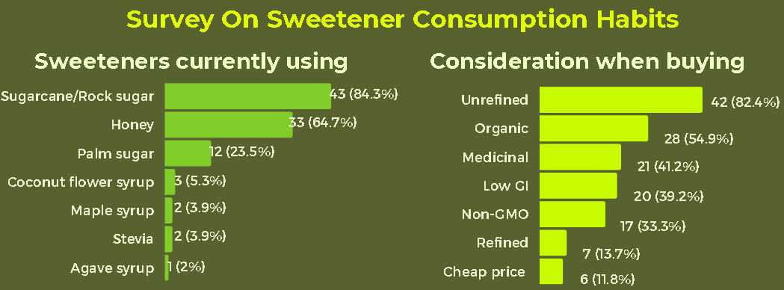
Figure 2. Survey on sweetener consumption habits

To mitigate market risk, we performed a survey on sweetener consumption habits via social network. When asked about the sweeteners currently using, 84% responders use sugarcane, 65% use honey, 24% use palm sugar and less than 6% use diabetic-friendly sweetener such as coconut flower syrup, stevia, agave syrup. However, when asked about their considerations when buying, more than 40% consider the healthy characteristics such as unrefined, organic, having medicinal properties, or low GI. Being cheap and refined is considered by less than 15% responders. This result means people want healthy and nutritious sweeteners, but they are not currently using it.

The market risks relevant to Tr'din syrup are:

a. Competition risk [3]:
This is one of the biggest risks a startup faces. If there are too many competitors in the market, it is difficult to make customers choose us in the crowds. The competition will be fierce and become a cheapest-price race in which only those with strong capital can survive.

For competition risk, if we consider the whole sweetener market, the risk is very high as they are dominated by sugarcane (85%) and honey (65%). However, if we consider only the low calorie /low GI /diabetic-friendly sweetener such as coconut flower syrup, maple syrup or stevia... the competition risk is low because there are less competitors and they all have less than 6% usage. But this is a niche market with high consumer adoption risk.

b. Consumer adoption risk [3]:
This is another important risk when a product cannot find customers willing to buy it, due to the product not suiting their needs, or failing to find and persuade the potential customers.

For consumer adoption risk, when we consider the surveyed consideration when buying, we find that more than 40% prefer low GI, medicinal, organic, unrefined features, while less than 15% require refined or cheap price. So the consumers are considering, but not currently using. If we have the right and strong enough marketing strategy so that consumers accept our product, we will have a big market. This is a high-risk high-reward game, so I think the consumer adoption risk is 3.5/5. We must have a strong and effective marketing strategy to succeed.

c. Price fluctuation risk [3]:
This risk is when the product price changes because of market conditions. The price fluctuation risk of Tr’din syrup is low because we provide our own raw material for production in Tay Giang area. By having control of our supply, we have more control of our price.

d. Economic fluctuation risk:
This risk is when the economy changes, it will lead to changes in consumer behavior and the product’s demands. The current market fluctuation risk is high because the economic downturn recently caused consumers to reduce their spending, so they may prefer cheap products like sugarcane rather than more nutritious and expensive products like Tr'din syrup.

In summary, for the general sweetener market, the competition risk is high. For the nutritious /low calorie /low GI sweetener market, the consumer adoption risk is high. The price fluctuation risk is low, but the market fluctuation risk is high in this economic downturn. Overall, I believe the market risk of Tr'din syrup is 3.5/5.

Recommendations
To mitigate market risk, we must address the consumer adoption risk, since we cannot do anything about the market fluctuation risk because of this economic downturn except to wait it out. We must have a strong and effective market strategy which consist of:

2.1. Start early with pilot sales & marketing:
Our survey indicates a large gap between what consumers want and what they are actually buying. This could be a big opportunity, but could also be a false signal. To assess the reality, we should start early with pilot sales & marketing activity: to produce, do marketing and sell in small batches to gain real experience about consumers and their willingness to buy our products. Based on their responses, we can learn more about the market, our potential customer segment, and what are the effective marketing strategies. We must start early to gain real life experience early and start learning early.

2.2. Increase the awareness of our products & customer engagement:
Before willing to buy, consumers must trust Tr'din syrup to be organic, nutritious, and medicinal sweetener that will improve their health. They must be aware and be educated about Tr'din syrup. To achieve this, we must do the following actions
- Establish websites, social media pages and ads on Facebook, Zalo, Youtube to inform and educate consumers about the benefits of Tr'din syrup.
- Establish shops on e-commerce platforms such as Shopee or Tiki to show our presence
- Create customer support and marketing teams to create marketing / education material and to engage customers

2.3. Form strategic partnerships with distributors and producers of health products:
They are established agents in the market. We supply them with a good product at a competitive price, they help us enter the market and reach their customer base.

3. Team, Human Resource, Governance and Leadership Risk: 3.5/5
There is no way one person can do everything. A company needs a great team to operate and an advising board - mentors, consultants, confidantes and even startup incubators for help and guidance. For a team and a board to work together effectively, we need good governance and strong leadership to facilitate exchanging information and making decisions. Team risk, human resource risk, governance and leadership risks are risks associated with failing to build a team and manage the human resource to operate the company, or failing to make people work together, communicate and stay informed to make sound decisions. Team and HR issues account for 18% startup failure, the 2nd most common cause.

Currently Tr'din syrup project only produces in small batches. There are workers and a few production managers and accountants for small operations, but there are no personnels for sales, marketing, or customer service. Thankfully, there is support from DNES - Da Nang Entrepreneur Support, and consultancy from several technical and business experts. Tr'din syrup project needs to gradually build up the team to operate the company, as well as the governance and leadership to work effectively.

Overall, I judge the team, human resource, governance and leadership risk is 3.5/5 as there are many to be built and learned. However, with the available support and consultancy, I hope it will be built well.

4. Financial Risk: 3.5/5
Financial risk consists of lack of funding, lack of available capital, or failing to generate revenue. This leads to cash flow problems, unable to financially sustain company operations and bankruptcy. Overall, financial issues account for 16% startup failure, the 3rd most common cause [1].

Currently Tr'din syrup project only produces in small batches and the project is waiting for a major investment of about 1 billion VND for mass production. When the investment comes, we will scale up everything from production to logistics to marketing to sales. However, there is no detailed financial planning.

Overall, I judge the financial risk as 3.5/5 since we have not had the financial planning, and there are many things to do for scaling up. A good thing is currently the business is small so the running cost is also small. Everything waits for a major investor to start our mass production.

5. Regulatory and Compliance Risk: 2/5
Regulatory and compliance risks are difficulties in following the regulatory framework, getting licenses, certificates, permits related to the product market. Failing to follow the regulatory framework or get the required licenses and certificates would cause the company to be fined and have to stop operation. Legal issues account for 2% startup failure [1]

Tr'din syrup is an organic natural sweetener that is low GI and diabetic-safe. We wish to sell it first as an organic natural sweetener that improves health, second as a low GI and diabetic-safe sweeteners for diabetes or those who want to avoid excessive sugar intake. In order to comply with the regulatory and getting licenses for such product, we need the following licenses / certificates:
- For production
  - Factory ISO certificate
  - ATTP cleanliness
  - Environment impact evaluation
  - Green production and carbon-neutral certificate
- For organic natural sweetener
  - Food safety certificate
  - Organic certificate
  - Nutrition content certificate
- For low GI and diabetic-safe sweetener
  - Low GI certificate
  - Diabetic-safe certificate

We have performed several laboratory tests to evaluate the potential of Tr'din syrup to obtain those certificates, so the risk is 2/5. However, to really obtain and maintain them, we need money. This amount will be included in the operation startup cost that is waiting for investors in section 4.

6. Operational and Scalability Risk: 3.5/5
Operational and scalability risk are related to difficulties in scaling operations, managing growth, optimization processes, and building organizational capacity. Failing to scale will lead to interrupt-prone, inefficient and wasteful operations, late deliveries which constraint organization growth, reduce its ability to compete or even cause it to fail. Sub-optimal operations account for 2% startup failure [1].

Currently the Tr'din syrup project only produces in small batches. In order to start large scale production, we first need to hire sales and marketing managers to start expanding our market. We need to invest a lot in marketing. Then we will build a factory according to ISO standard and purchase the required machinery. Then we purchase a truck for large batch transportation, and build a warehouse to store a larger amount of goods.

We are waiting for a major investment in order to start building our operation. With the available support and consultancy, I hope it will be built well. Overall, I judge the operation and scalability risk as 3.5/5 since there are many things to do.

7. Environmental Risk: 2/5
Environment risks are issues related to environmental sustainability, natural disasters, climate change, and resource scarcity. It can lead to supply chain disruption, increased cost, loss of reputation, and compromised social and environmental objectives.

The Tr'din syrup project aims to sustainably harvest Tr'din forests in Tay Giang to improve the economy of mountain villages in Tay Giang and protect the environment by eliminating incentive for forest foraging and creating economic incentive to protect the forest. So we have built-in environmental protection in our company goals. Nevertheless, we can have these possible environmental risks:
- Heavy rain and wind may cause landslides that block the transportation in and out of the region. To mitigate this risk, we may establish warehouses outside the vulnerable area, so if the roads get blocked, we can still use the remaining stocks in our warehouses for deliveries.
- The Tr'din resin harvesting process may increase traffic in the forest, causing damage to the forest environment. To mitigate this risk, we will establish the company rules to protect the forest environment, educate the workers on the importance of protecting the forest, and enforce a reasonable fine for violating the rules.

I believe we can reasonably prevent the damage to the forest while harvesting Tr'din resin. However, the landslide problem cannot be completely prevented. Overall the risk is 2/5.

8. Social Impact Risk: 3.5/5
Social impact risks are difficulties causing the project to achieve the intended social outcomes. The Tr'din syrup project aims to improve the economy and the quality of life of Tay Giang villages by creating jobs, providing incomes and improving commerce. The social impact risk is when the Tr'din syrup project fails to do so.
If the Tr’din syrup project achieves commercial success, it will definitely achieve the social impact goals of creating jobs, providing incomes and improving commerce to Tay Giang mountain area. Otherwise, it will fail to do so. So the social impact risk is equal to the overall Tr’din syrup project failure risk, which I think to be 3.5/5.

III. Summary
In this case study, we performed risk management for the Tr’din syrup project. We have analyzed the project’s current status with respect to the common risk categories, identify potential issues and recommend the mitigating actions. Here is the overall evaluation for each risk category:
- Product Risk: 1/5
- Market Risk: 3.5/5
- Team, Human Resource, Governance and Leadership Risk: 3.5/5
- Financial Risk: 3.5/5
- Regulatory and Compliance Risk: 2/5
- Operational and Scalability Risk: 3.5/5
- Environmental Risk: 2/5
- Social Impact Risk: 3.5/5
The 3 most common causes of startup failures: market risk, financial risk, team & human resource risk [1] are evaluated from 3.5/5. The project needs to quickly have mitigating actions to address these risks, such as
- Have a detailed financial plan to estimate the cost for setup production, recruitment, delivery, marketing, customer engagement, education, sales etc..
- Find an investor to finance it.
- Start small and start early once we have the finance to have real experience and fine tune the process to find the most effective and efficient approach
  - Start recruitment to build up the team, especially the sales and marketing team.
  - Grow our market with sales & marketing
  - Establish the management & governance process to ensure smooth operations
  - Find partners and distributors to sign supply / distribution contracts.
  - Scale up production
The immediate action now is to have a detailed financial plan for estimating the cost for scaling the company operations, and to find an investor to finance it. After we find an investor, we can start putting the plan into practice, start small, start early, and improve the operations to reduce the risk as we go.

References
[1] Startup Failure Rate Statistics (2023)
https://explodingtopics.com/blog/startup-failure-stats
[2] When Launching Your Startup, Consider These 5 Risks
https://www.entrepreneur.com/starting-a-business/when-launching-your-startup-consider-these-5-risks/234094
[3] The Different Types of Risk for Startups
https://fastercapital.com/content/The-Different-Types-of-Risk-for-Startups.html
[4] Natural Sweeteners Market
https://www.gminsights.com/industry-analysis/natural-sweeteners-market

